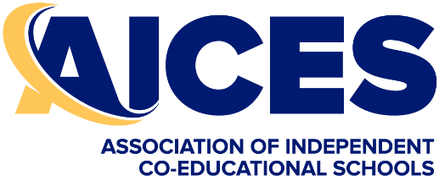
Mandatory Clothing if Selected in an AICES Team
Orders must be placed online with Elite Sports within 48 hours of selection. After 48 hours there is no guarantee that the uniform will arrive before the CIS Trials.
Students may purchase any additional items they want
Sport | Mandatory Clothing to Purchase  (unless already owned)
Athletics  Do not order online. Orders will be processed at AICES Athletics | AICES Athletics Singlet and  AICES Polo Shirt or AICES T-Shirt
Basketball | AICES T-Shirt
Cricket | AICES Polo Shirt or AICES T-Shirt
Cross Country  Do not order online. Orders will be processed at AICES XC | AICES Athletics Singlet and  AICES Polo Shirt or AICES T-Shirt
Diving | AICES Polo Shirt or AICES T-Shirt
Football | AICES Polo Shirt or AICES T-Shirt  AICES Jacket  AICES Socks
Hockey | AICES Polo Shirt or AICES T-Shirt  AICES Socks
Netball | AICES Polo Shirt or AICES T-Shirt
Rugby Union – Boys  Do not order online. Orders will be processed at training | AICES Polo Shirt  AICES T-Shirt  AICES Tie #  AICES Jacket  AICES Rugby Shorts  AICES Rugby Socks
Rugby 7’s - Girls | AICES Polo Shirt or AICES T-Shirt  AICES Rugby Socks
Softball | AICES Polo Shirt or AICES T-Shirt
Swimming  Do not order online. Orders will be processed at AICES Swimming | AICES Swimming Cap  AICES Polo Shirt or AICES T-Shirt
Tennis | AICES Polo Shirt or AICES T-Shirt
Touch Football | AICES Polo Shirt or AICES T-Shirt
Water Polo | AICES Polo Shirt or AICES T-Shirt

